SIMATS ENGINEERING
ASSESSMENT TOOL 1
COURSE NAME: Database Management Systems
COURSE CODE: CSA05

COURSE OUTCOME COVERED

CO2: Apply the relational model, relational algebra, SQL query structures, and views to solve database querying and data manipulation problems. (BL3, BL6)

Activity Tool: Analytical Problem Solving (High)
Assessment Tool Weightage: 40%

QUESTIONS
Q.N o | Question | Bloom's Level
1 | Given a set of relations and sample data, write SQL queries to retrieve specific information using joins and subqueries, and explain the logic used.  Bloom’s Level: BL3 – Apply | BL4 – Analyze
2 | Using relational algebra, formulate expressions to solve complex queries such as retrieving records that satisfy multiple conditions across relations.  Bloom’s Level: BL4 – Analyse | BL5 – Evaluate
3 | Given a real-world scenario (e.g., banking or student system), design a relational schema and construct appropriate SQL queries for data retrieval and updates.  Bloom’s Level: BL6 – Create | BL6 – Create
4 | Analyse a given SQL query with nested subqueries and predict its output, explaining each step of execution.  Bloom’s Level: BL4 – Analyze | BL6 – Create
5 | Compare different SQL approaches (joins vs subqueries) for solving the same problem and evaluate their efficiency.  Bloom’s Level: BL5 – Evaluate | BL4 – Analyze
6 | Design and implement views for a database system to provide restricted data access, and justify their use for security and abstraction. Bloom’s Level: BL6 – Create | BL5 – Evaluate
7 | Given a database schema, write relational algebra expressions and convert them into equivalent SQL queries, analyzing differences in representation.  Bloom’s Level: BL4 – Analyze | BL4 – Analyze
8 | Optimize a set of inefficient SQL queries by restructuring them using joins, indexing concepts, or views, and evaluate performance improvements.  Bloom’s Level: BL5 – Evaluate | BL5 – Evaluate
9 | Develop a complex SQL query involving grouping, aggregation, and nested queries to solve a real-world problem.  Bloom’s Level: BL6 – Create | BL6 – Create
10 | Given multiple relations, analyze the query requirements and decide whether to use views, joins, or subqueries, justifying your choice with reasoning.  Bloom’s Level: BL5 – Evaluate | BL5 – Evaluate

Criteria | Level 4 (Exemplary) | Level 3 (Proficient) | Level 2 (Developing) | Level 1  (Beginning  )
Problem  Understandin g | Clearly interprets problem,  identifies all parameters and  requirements accurately | Understand s problem  with minor gaps | Partial understandin  g; misses key elements | Misinterpret s or unable to  understand problem
Method  Selection | Selects most appropriate  method/formul a with strong justification | Selects correct  method with minor errors | Inappropriate or partially correct method | Unable to select method
Solution Process | Logical, systematic  steps with correct  approach throughout | Mostly correct  steps with minor mistakes | Disorganized steps;  multiple errors | No clear process
Accuracy of Calculation | All calculations accurate; | Minor calculation errors | Frequent errors;  incorrect final answer | No valid calculations

Code of Conduct:

I DHANUSHYA RB (192565033) certify that this submission is my original work and that I have adhered to the guidelines specified for this assessment. I understand that any violation of academic integrity rules will result in disciplinary action.

Signature of the student:

Dhanushya RB

RUBRICS FOR CALCULATION:

 | correct final answer
Interpretation of Results | Clearly interprets  results with units and  engineering relevance | Basic interpretatio  n with minor omissions | Limited or unclear interpretation | No  interpretatio n

SCENARIO-BASED ANSWERS

Question 1
A university stores student and course data in a single table. Analyze the structure and identify normalization issues, then redesign it up to 3NF.
Introduction
Many university information systems begin with a single flat table that stores student details, department information, course details, faculty details and marks together. While this appears convenient for data entry, it violates the principles of relational database design. This scenario is analyzed below by examining the existing structure, identifying the anomalies it causes, and systematically redesigning the schema up to the Third Normal Form (3NF).
Scenario Analysis
The university maintains one table, STUDENT_COURSE, that records the student's personal details, the department they belong to, the courses they are enrolled in, the faculty teaching each course, and the marks obtained. Because a student can enroll in multiple courses, and each course can have many students, the table contains repeating groups and multivalued columns. A sample of the existing (unnormalized) structure is shown below.
Table 1: Existing Unnormalized Schema (STUDENT_COURSE)
Student_ID | Student_Name | Dept_Name | HOD_Name | Course_ID | Course_Name | Faculty_Name | Marks
S101 | Arun Kumar | CSE | Dr. Meena | C201, C202 | DBMS, OS | Dr. Raja, Ms. Priya | 88, 79
S102 | Divya R | ECE | Dr. Suresh | C301 | Signals | Dr. Vino | 91
S103 | Arun Kumar | CSE | Dr. Meena | C203 | Networks | Mr. Kannan | 84
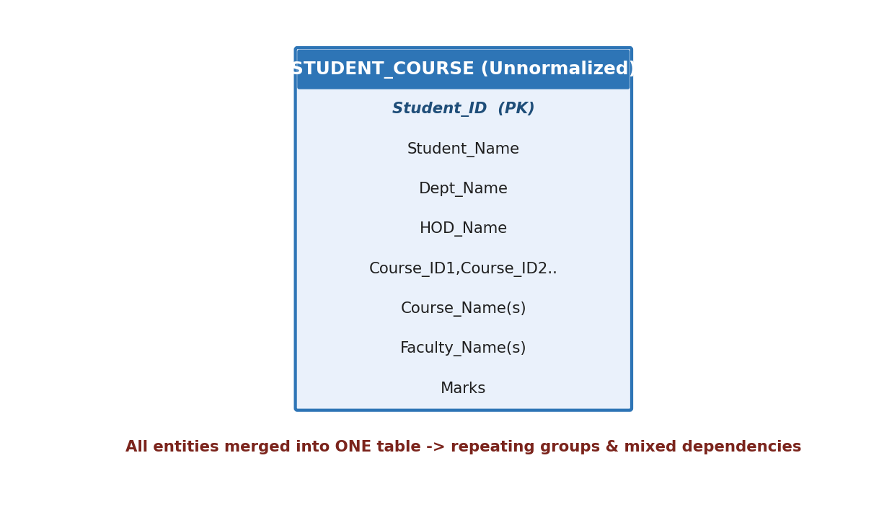
Figure 1: ER representation of the unnormalized single-table design
Identification of Problems
Analyzing the scenario against the rules of normalization reveals the following anomalies, caused primarily by storing multivalued attributes (Course_ID, Course_Name, Faculty_Name, Marks) and transitive dependencies (Dept_Name and HOD_Name depending on Student_ID only through the department) within one table.
Table 2: Problems Identified in the Existing Schema
Anomaly Type | Description | Example from Scenario
Insertion Anomaly | A new course cannot be added unless a student has already enrolled in it | Course C401 cannot be stored until a student registers for it
Update Anomaly | Repeated data must be updated in multiple rows, risking inconsistency | Changing HOD_Name for CSE requires updating every CSE student's row
Deletion Anomaly | Deleting a student's record may remove course/faculty information entirely | Removing S102 deletes the only record of the Signals course
Repeating Groups (violates 1NF) | Course_ID, Course_Name, Faculty_Name and Marks store multiple values in a single cell | S101 stores 'C201, C202' in one field
Functional Dependencies Identified
Table 3: Functional Dependencies (FDs)
FD No. | Functional Dependency | Type
FD1 | Student_ID -> Student_Name, Dept_Name | Partial/Full (on composite key)
FD2 | Dept_Name -> HOD_Name | Transitive dependency
FD3 | Course_ID -> Course_Name, Faculty_Name | Full functional dependency
FD4 | (Student_ID, Course_ID) -> Marks | Full functional dependency on composite key
Proposed Solution
The scenario requires decomposition of the single table into multiple relations so that each relation represents exactly one real-world concept, and every non-key attribute depends only on the whole primary key of its own relation. The redesign proceeds through 1NF, 2NF and 3NF as shown below.
Step-by-Step Explanation
- Step 1 (1NF): Eliminate repeating groups. Each course a student takes is placed in its own row, so the enrollment table now has one course and one mark per row.
- Step 2 (2NF): Remove partial dependencies. Since (Student_ID, Course_ID) is the composite key of the enrollment relation, attributes such as Student_Name and Course_Name (which depend only on part of the key) are moved out into STUDENT and COURSE relations.
- Step 3 (3NF): Remove transitive dependencies. HOD_Name depends on Dept_Name, not directly on Student_ID, so it is moved into a separate DEPARTMENT relation, referenced from STUDENT via Dept_ID.
- Step 4: Establish primary keys and foreign keys to preserve the original relationships without redundancy.
Table 4: Resulting 3NF Relations
Relation | Attributes | Primary Key | Foreign Key
DEPARTMENT | Dept_ID, Dept_Name, HOD_Name | Dept_ID | -
STUDENT | Student_ID, Student_Name, DOB, Dept_ID | Student_ID | Dept_ID -> DEPARTMENT
COURSE | Course_ID, Course_Name, Credits, Dept_ID | Course_ID | Dept_ID -> DEPARTMENT
ENROLLMENT | Enroll_ID, Student_ID, Course_ID, Marks, Grade | Enroll_ID | Student_ID -> STUDENT, Course_ID -> COURSE
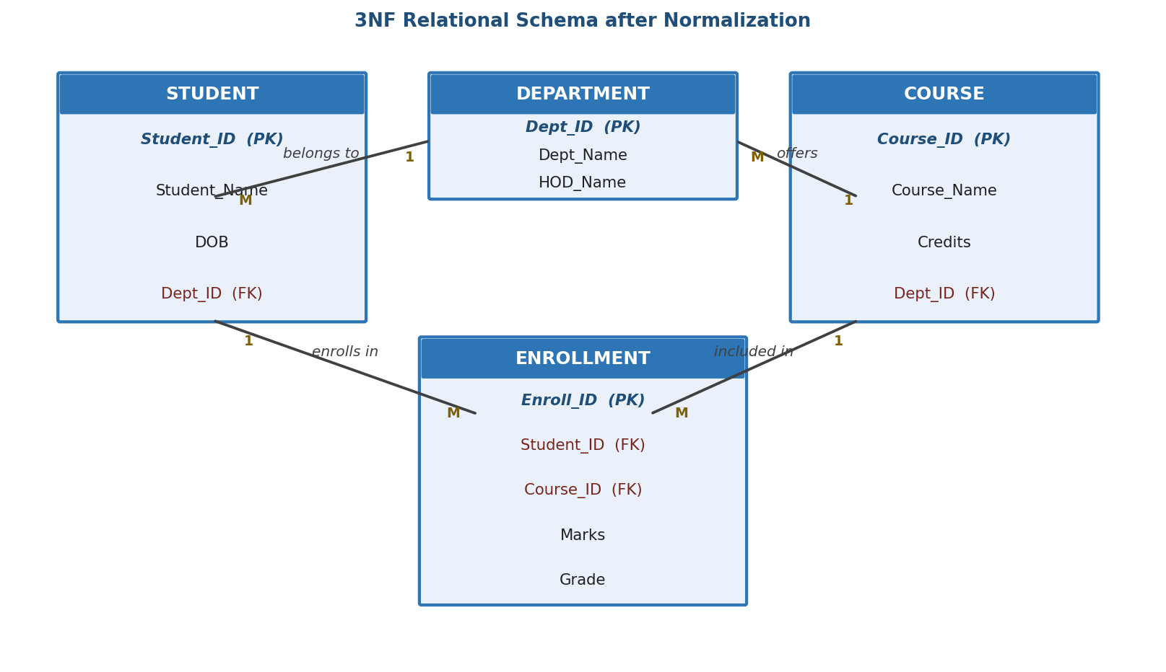
Figure 2: 3NF Relational Schema for the University Database
Required SQL
CREATE TABLE DEPARTMENT (
Dept_ID VARCHAR(10) PRIMARY KEY,
Dept_Name VARCHAR(50) NOT NULL,
HOD_Name VARCHAR(50)
);
CREATE TABLE STUDENT (
Student_ID VARCHAR(10) PRIMARY KEY,
Student_Name VARCHAR(50) NOT NULL,
DOB DATE,
Dept_ID VARCHAR(10),
FOREIGN KEY (Dept_ID) REFERENCES DEPARTMENT(Dept_ID)
);
CREATE TABLE COURSE (
Course_ID VARCHAR(10) PRIMARY KEY,
Course_Name VARCHAR(50) NOT NULL,
Credits INT DEFAULT 3,
Dept_ID VARCHAR(10),
FOREIGN KEY (Dept_ID) REFERENCES DEPARTMENT(Dept_ID)
);
CREATE TABLE ENROLLMENT (
Enroll_ID INT AUTO_INCREMENT PRIMARY KEY,
Student_ID VARCHAR(10),
Course_ID VARCHAR(10),
Marks DECIMAL(5,2) CHECK (Marks BETWEEN 0 AND 100),
Grade CHAR(2),
FOREIGN KEY (Student_ID) REFERENCES STUDENT(Student_ID),
FOREIGN KEY (Course_ID) REFERENCES COURSE(Course_ID)
);
-- Sample query: list each student with the courses and marks
SELECT s.Student_Name, c.Course_Name, e.Marks
FROM STUDENT s
JOIN ENROLLMENT e ON s.Student_ID = e.Student_ID
JOIN COURSE c ON e.Course_ID = c.Course_ID
ORDER BY s.Student_Name;
Justification
The decomposition satisfies 3NF because every non-key attribute in each relation depends only on the primary key of that relation and not on any other non-key attribute. DEPARTMENT removes the transitive dependency of HOD_Name; STUDENT and COURSE remove the partial dependency of descriptive attributes on the composite enrollment key; and ENROLLMENT isolates the many-to-many relationship between students and courses using a surrogate key, which also allows a student to retake a course without violating a primary key constraint.
Conclusion
The original single-table design mixed four distinct entities and caused insertion, update and deletion anomalies due to repeating groups and transitive dependencies. By systematically applying 1NF, 2NF and 3NF, the university database is redesigned into four well-structured relations - DEPARTMENT, STUDENT, COURSE and ENROLLMENT - that eliminate redundancy while fully preserving the information and relationships present in the original scenario.

Question 2
A company database contains employee and department details. Design appropriate SQL queries to retrieve employees working in multiple departments and justify your approach.
Introduction
Modern organizations frequently allow an employee to be assigned to more than one department, for example a business analyst who supports both the Finance and IT departments. Retrieving such employees correctly requires a schema that captures the many-to-many relationship, together with SQL queries that group and filter assignment records rather than relying on a single Dept_ID column that can hold only one value.
Scenario Analysis
The company database stores Employee and Department details. If Dept_ID were stored directly inside the EMPLOYEE table, an employee could only ever belong to one department, which does not match the scenario where employees are shared across departments. Therefore, the relationship between employees and departments is many-to-many and must be represented through a junction (bridge) relation, EMP_DEPT, that records each assignment separately.
Table 1: Sample EMPLOYEE Data
Emp_ID | Emp_Name | Designation | Salary
E01 | Ramesh Babu | Analyst | 55000
E02 | Sneha Iyer | Developer | 62000
E03 | Vikram Rao | Consultant | 70000
Table 2: Sample EMP_DEPT Assignment Data
Emp_ID | Dept_ID | Role_In_Dept
E01 | D01 (Finance) | Data Analyst
E01 | D02 (IT) | Support Analyst
E02 | D02 (IT) | Developer
E03 | D01 (Finance) | Auditor
E03 | D03 (HR) | Consultant
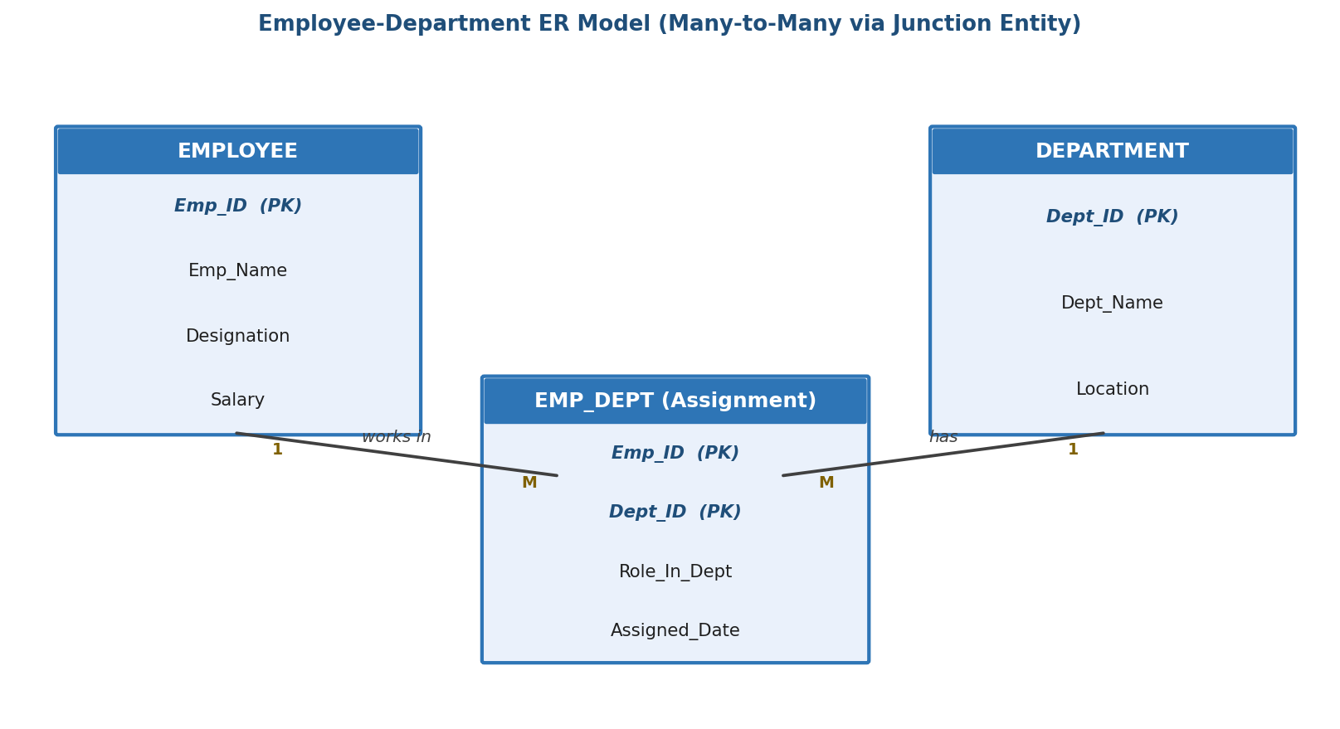
Figure 1: Employee-Department ER Model with EMP_DEPT junction entity
Identification of Problems
- A single foreign key column in EMPLOYEE cannot represent an employee who belongs to several departments simultaneously.
- Without a dedicated assignment table, identifying employees in multiple departments would require unreliable string-matching on a comma-separated column.
- Reporting queries (e.g., "employees in more than one department") need aggregation, which is only possible when each assignment is stored as an individual row.
Proposed Solution
A junction relation EMP_DEPT is introduced with a composite primary key (Emp_ID, Dept_ID), resolving the many-to-many relationship into two one-to-many relationships. Employees working in multiple departments can then be identified using GROUP BY on Emp_ID with a HAVING COUNT(DISTINCT Dept_ID) > 1 condition.
Step-by-Step Explanation
- Step 1: Group all assignment rows in EMP_DEPT by Emp_ID.
- Step 2: Count the distinct departments associated with each employee.
- Step 3: Filter groups having more than one distinct department using HAVING.
- Step 4: Join back to EMPLOYEE and DEPARTMENT to display readable names instead of only IDs.
Required SQL
CREATE TABLE EMPLOYEE (
Emp_ID VARCHAR(10) PRIMARY KEY,
Emp_Name VARCHAR(50) NOT NULL,
Designation VARCHAR(30),
Salary DECIMAL(10,2) CHECK (Salary > 0)
);
CREATE TABLE DEPARTMENT (
Dept_ID VARCHAR(10) PRIMARY KEY,
Dept_Name VARCHAR(50) NOT NULL,
Location VARCHAR(50)
);
CREATE TABLE EMP_DEPT (
Emp_ID VARCHAR(10),
Dept_ID VARCHAR(10),
Role_In_Dept VARCHAR(40),
Assigned_Date DATE DEFAULT CURRENT_DATE,
PRIMARY KEY (Emp_ID, Dept_ID),
FOREIGN KEY (Emp_ID) REFERENCES EMPLOYEE(Emp_ID),
FOREIGN KEY (Dept_ID) REFERENCES DEPARTMENT(Dept_ID)
);
-- Query 1: Employees working in more than one department
SELECT e.Emp_ID, e.Emp_Name, COUNT(DISTINCT ed.Dept_ID) AS Dept_Count
FROM EMPLOYEE e
JOIN EMP_DEPT ed ON e.Emp_ID = ed.Emp_ID
GROUP BY e.Emp_ID, e.Emp_Name
HAVING COUNT(DISTINCT ed.Dept_ID) > 1;
-- Query 2: Same result using a correlated subquery
SELECT Emp_ID, Emp_Name
FROM EMPLOYEE e
WHERE (SELECT COUNT(DISTINCT Dept_ID) FROM EMP_DEPT WHERE Emp_ID = e.Emp_ID) > 1;
-- Query 3: Department-wise listing of these multi-department employees
SELECT e.Emp_Name, d.Dept_Name, ed.Role_In_Dept
FROM EMP_DEPT ed
JOIN EMPLOYEE e ON e.Emp_ID = ed.Emp_ID
JOIN DEPARTMENT d ON d.Dept_ID = ed.Dept_ID
WHERE e.Emp_ID IN (
SELECT Emp_ID FROM EMP_DEPT GROUP BY Emp_ID HAVING COUNT(DISTINCT Dept_ID) > 1
)
ORDER BY e.Emp_Name;
-- Reusable view for reporting
CREATE VIEW Multi_Dept_Employees AS
SELECT e.Emp_ID, e.Emp_Name, COUNT(DISTINCT ed.Dept_ID) AS Dept_Count
FROM EMPLOYEE e JOIN EMP_DEPT ed ON e.Emp_ID = ed.Emp_ID
GROUP BY e.Emp_ID, e.Emp_Name
HAVING COUNT(DISTINCT ed.Dept_ID) > 1;
Table 3: Expected Output of Query 1
Emp_ID | Emp_Name | Dept_Count
E01 | Ramesh Babu | 2
E03 | Vikram Rao | 2
Justification
The GROUP BY / HAVING approach is preferred over the correlated subquery in Query 2 because it executes as a single set-based aggregation and scales efficiently for large EMP_DEPT tables, whereas a correlated subquery re-evaluates for every employee row. The junction table design also allows additional attributes, such as Role_In_Dept and Assigned_Date, to be captured per assignment - information that could not be stored if a single Dept_ID column were used.
Conclusion
By modeling the employee-department relationship through a dedicated EMP_DEPT junction relation, and applying grouping and aggregation in SQL, the company can accurately and efficiently identify employees who are shared across multiple departments, supporting better resource allocation and reporting.

Question 3
Given a relation with multiple functional dependencies, determine the candidate keys and check whether the relation satisfies BCNF. If not, decompose it.
Introduction
Boyce-Codd Normal Form (BCNF) is a stricter version of 3NF that requires every determinant of a functional dependency to be a candidate key. This scenario examines a relation, PROJECT_ASSIGNMENT, that records which employee works on which project under which manager, derives its candidate keys from the given functional dependencies, tests it against BCNF, and decomposes it where a violation is found.
Scenario Analysis
Consider the relation PROJECT_ASSIGNMENT (Emp_ID, Project_ID, Manager_ID, Emp_Dept) with the following functional dependencies collected from the organization's business rules: each project has exactly one manager, and each manager manages exactly one project; every employee belongs to a single department. This models a common real-world case where a determinant (Manager_ID) is not itself a full candidate key, which is a classic trigger for BCNF violation.
Table 1: Given Functional Dependencies
FD No. | Functional Dependency | Business Meaning
FD1 | (Emp_ID, Project_ID) -> Manager_ID, Emp_Dept | An employee's assignment to a project fixes the manager and department
FD2 | Project_ID -> Manager_ID | Each project has exactly one manager
FD3 | Manager_ID -> Project_ID | Each manager manages exactly one project
Candidate Key Determination
The attribute closure of (Emp_ID, Project_ID) is computed as follows: starting with {Emp_ID, Project_ID}, FD1 adds Manager_ID and Emp_Dept, giving the closure {Emp_ID, Project_ID, Manager_ID, Emp_Dept}, which covers all attributes of the relation. Hence (Emp_ID, Project_ID) is a candidate key. Because Project_ID <-> Manager_ID (FD2 and FD3 together form a one-to-one correspondence), (Emp_ID, Manager_ID) also has closure equal to all attributes and is therefore an additional candidate key.
Table 2: Candidate Keys
Candidate Key | Closure Result | Status
{Emp_ID, Project_ID} | {Emp_ID, Project_ID, Manager_ID, Emp_Dept} | Valid candidate key
{Emp_ID, Manager_ID} | {Emp_ID, Manager_ID, Project_ID, Emp_Dept} | Valid candidate key
{Project_ID} | {Project_ID, Manager_ID} only | Not a candidate key (Emp_Dept not derivable)
Identification of Problems (BCNF Check)
BCNF requires that for every non-trivial FD X -> Y in the relation, X must be a superkey. FD2 (Project_ID -> Manager_ID) and FD3 (Manager_ID -> Project_ID) both have determinants that are NOT superkeys of PROJECT_ASSIGNMENT, since neither Project_ID nor Manager_ID alone can derive Emp_Dept. This is a direct BCNF violation.
Table 3: BCNF Violation Analysis
FD | Determinant | Is Determinant a Superkey? | BCNF Status
(Emp_ID, Project_ID) -> Manager_ID, Emp_Dept | {Emp_ID, Project_ID} | Yes | Satisfies BCNF
Project_ID -> Manager_ID | {Project_ID} | No | Violates BCNF
Manager_ID -> Project_ID | {Manager_ID} | No | Violates BCNF
Proposed Solution
Since Project_ID -> Manager_ID violates BCNF, the relation is decomposed using the standard BCNF decomposition algorithm: split into R1 containing the violating FD's determinant and dependent attributes, and R2 containing the determinant together with the remaining attributes.
Step-by-Step Explanation
- Step 1: Select the violating FD, Project_ID -> Manager_ID, whose determinant is not a superkey.
- Step 2: Create R1(Project_ID, Manager_ID) - contains the determinant and the attributes it determines.
- Step 3: Create R2(Emp_ID, Project_ID, Emp_Dept) - contains the determinant Project_ID plus all attributes not moved to R1.
- Step 4: Verify each resulting relation independently against BCNF using its own functional dependencies.
Table 4: Final Decomposed Relations (BCNF)
Relation | Attributes | Candidate Key | FDs Holding | BCNF Verified
PROJECT_MANAGER | Project_ID, Manager_ID | Project_ID or Manager_ID | Project_ID <-> Manager_ID | Yes
EMP_PROJECT_DEPT | Emp_ID, Project_ID, Emp_Dept | {Emp_ID, Project_ID} | (Emp_ID, Project_ID) -> Emp_Dept | Yes
Required SQL
-- Original (BCNF-violating) relation, for reference
-- PROJECT_ASSIGNMENT(Emp_ID, Project_ID, Manager_ID, Emp_Dept)
CREATE TABLE PROJECT_MANAGER (
Project_ID VARCHAR(10) PRIMARY KEY,
Manager_ID VARCHAR(10) UNIQUE NOT NULL
);
CREATE TABLE EMP_PROJECT_DEPT (
Emp_ID VARCHAR(10),
Project_ID VARCHAR(10),
Emp_Dept VARCHAR(30) NOT NULL,
PRIMARY KEY (Emp_ID, Project_ID),
FOREIGN KEY (Project_ID) REFERENCES PROJECT_MANAGER(Project_ID)
);
-- Reconstructing the original view via JOIN (lossless-join verification)
CREATE VIEW Project_Assignment_View AS
SELECT e.Emp_ID, e.Project_ID, p.Manager_ID, e.Emp_Dept
FROM EMP_PROJECT_DEPT e
JOIN PROJECT_MANAGER p ON e.Project_ID = p.Project_ID;
Justification
The decomposition is lossless-join because the common attribute Project_ID is a key of PROJECT_MANAGER, satisfying the lossless-join test (R1 intersect R2 -> R1 or R1 intersect R2 -> R2). It is also dependency-preserving, since both FD2/FD3 (inside PROJECT_MANAGER) and FD1 (inside EMP_PROJECT_DEPT) can be checked without needing to join the tables. Each resulting relation now has only superkeys as determinants, satisfying BCNF.
Conclusion
The original PROJECT_ASSIGNMENT relation violated BCNF because Project_ID and Manager_ID, though not full candidate keys, functionally determined other attributes. Decomposing it into PROJECT_MANAGER and EMP_PROJECT_DEPT removes this anomaly while preserving both the original information and all functional dependencies, resulting in a schema that is fully in BCNF.

Question 4
A banking system requires secure data access. Design views and constraints to ensure data security and integrity for different types of users.
Introduction
Banking systems handle highly sensitive financial data and must be accessible to multiple categories of users - customers, tellers, and managers - each requiring a different level of visibility and control. This scenario designs a base schema together with restricted views, integrity constraints, and role-based privileges that jointly enforce both data security (who can see and change what) and data integrity (what values are permitted).
Scenario Analysis
The bank maintains CUSTOMER, ACCOUNT, TRANSACTION, EMPLOYEE, BRANCH and LOAN data. A customer should be able to see only their own account summary, a teller should be able to process transactions but not view loan approval details, and a manager should have full read access along with the ability to approve loans. Granting direct table access to every user would expose sensitive columns (such as another customer's balance) and risks accidental or malicious data corruption.
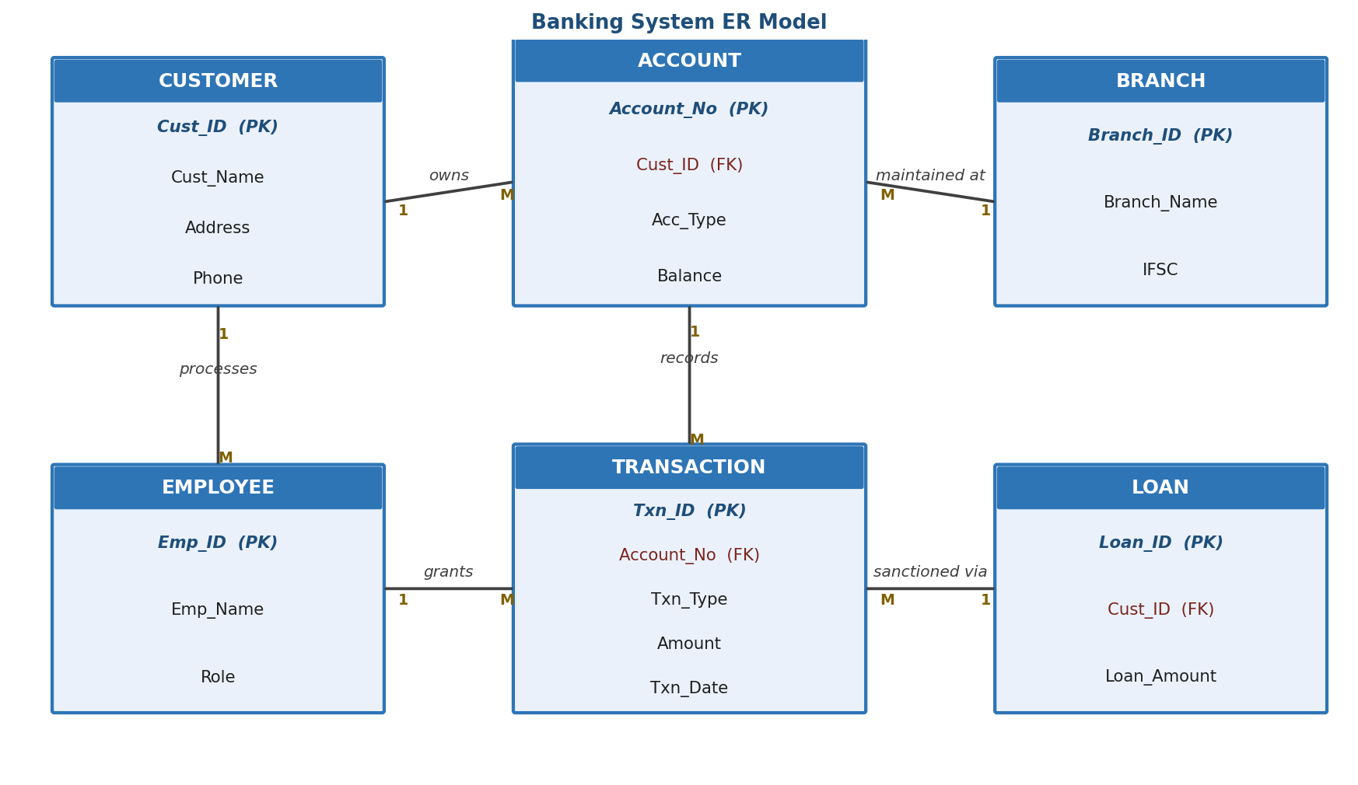
Figure 1: Banking System ER Model
Identification of Problems
Table 1: Security and Integrity Risks Identified
Risk | Description | Impact
Unrestricted table access | Users querying base tables directly can see all customers' data | Breach of confidentiality
No balance constraint | Balance column can be updated to a negative value | Violates business rule, financial inconsistency
No role separation | All employees share the same DB login and privileges | No accountability, excessive access
Missing referential checks | Transactions could reference a non-existent account | Orphaned/invalid records
Proposed Solution
A three-tier access model is proposed: (1) base tables with strong integrity constraints, (2) views that expose only the necessary columns/rows to each user category, and (3) database roles with GRANT/REVOKE privileges applied to those views instead of the base tables.
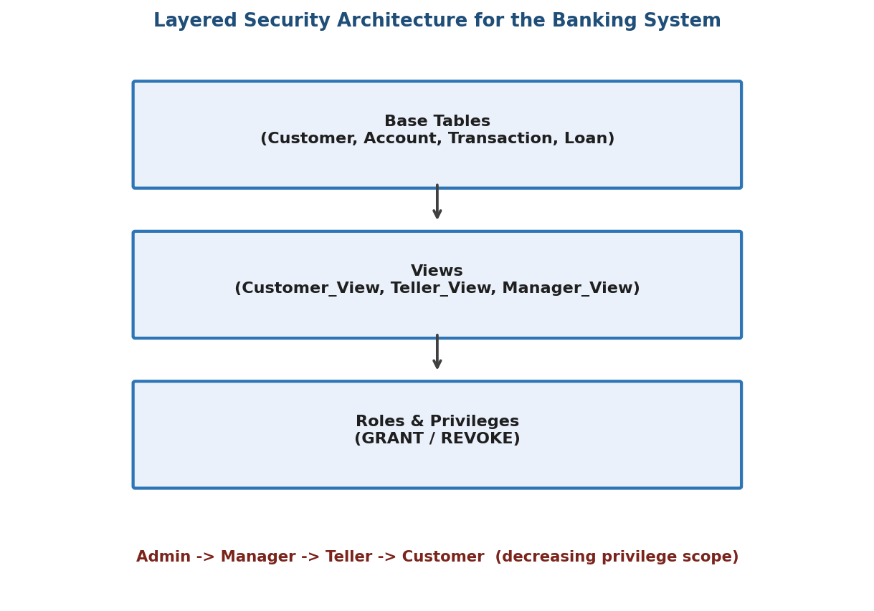
Figure 2: Layered Security Architecture (Tables -> Views -> Roles)
Step-by-Step Explanation
- Step 1: Define base tables with PRIMARY KEY, FOREIGN KEY, CHECK, NOT NULL, DEFAULT and UNIQUE constraints to guarantee data integrity.
- Step 2: Create a Customer_View exposing only the account owner's own accounts and balances (row-level filtering achieved via a WHERE clause bound to the session user).
- Step 3: Create a Teller_View that allows transaction processing without exposing loan approval or salary data.
- Step 4: Create a Manager_View with full read access, including loan and employee performance information.
- Step 5: Create three database roles - customer_role, teller_role, manager_role - and GRANT the minimum necessary privileges on the corresponding views only.
Table 2: Constraints Applied for Integrity
Constraint | Applied To | Purpose
PRIMARY KEY | Cust_ID, Account_No, Txn_ID, Loan_ID | Uniquely identifies each row
FOREIGN KEY | Account.Cust_ID, Transaction.Account_No | Preserves referential integrity
CHECK (Balance >= 0) | Account.Balance | Prevents negative account balances
CHECK (Amount > 0) | Transaction.Amount | Disallows zero/negative transactions
NOT NULL | Cust_Name, Account_No, Txn_Type | Ensures mandatory business data is present
DEFAULT CURRENT_DATE | Account.Opening_Date, Txn_Date | Automatically timestamps records
UNIQUE | Employee.Email, Branch.IFSC | Prevents duplicate identifiers
Table 3: Role-Based Privileges
Role | Access Granted | Access Denied
customer_role | SELECT on Customer_View (own account only) | TRANSACTION, LOAN, EMPLOYEE base tables
teller_role | SELECT, INSERT on Teller_View (deposits/withdrawals) | Loan approval, employee salary
manager_role | SELECT on all views, UPDATE on Loan approval status | Direct DELETE on TRANSACTION history
Required SQL
CREATE TABLE CUSTOMER (
Cust_ID VARCHAR(10) PRIMARY KEY,
Cust_Name VARCHAR(50) NOT NULL,
Address VARCHAR(100),
Phone VARCHAR(15) UNIQUE
);
CREATE TABLE ACCOUNT (
Account_No VARCHAR(15) PRIMARY KEY,
Cust_ID VARCHAR(10),
Acc_Type VARCHAR(20) NOT NULL,
Balance DECIMAL(12,2) DEFAULT 0 CHECK (Balance >= 0),
Opening_Date DATE DEFAULT (CURRENT_DATE),
FOREIGN KEY (Cust_ID) REFERENCES CUSTOMER(Cust_ID)
);
CREATE TABLE TRANSACTION_LOG (
Txn_ID INT AUTO_INCREMENT PRIMARY KEY,
Account_No VARCHAR(15),
Txn_Type VARCHAR(10) NOT NULL CHECK (Txn_Type IN ('DEPOSIT','WITHDRAW')),
Amount DECIMAL(12,2) CHECK (Amount > 0),
Txn_Date DATE DEFAULT (CURRENT_DATE),
FOREIGN KEY (Account_No) REFERENCES ACCOUNT(Account_No)
);
-- Customer-facing view: only their own account summary
CREATE VIEW Customer_View AS
SELECT a.Account_No, a.Acc_Type, a.Balance
FROM ACCOUNT a
WHERE a.Cust_ID = CURRENT_USER(); -- session-bound filtering
-- Teller view: process transactions, no loan/salary visibility
CREATE VIEW Teller_View AS
SELECT t.Txn_ID, t.Account_No, t.Txn_Type, t.Amount, t.Txn_Date
FROM TRANSACTION_LOG t;
-- Manager view: full oversight including loans
CREATE VIEW Manager_View AS
SELECT c.Cust_Name, a.Account_No, a.Balance, l.Loan_Amount, l.Status
FROM CUSTOMER c
JOIN ACCOUNT a ON c.Cust_ID = a.Cust_ID
LEFT JOIN LOAN l ON c.Cust_ID = l.Cust_ID;
-- Role-based access control
CREATE ROLE customer_role;
CREATE ROLE teller_role;
CREATE ROLE manager_role;
GRANT SELECT ON Customer_View TO customer_role;
GRANT SELECT, INSERT ON Teller_View TO teller_role;
GRANT SELECT ON Manager_View TO manager_role;
GRANT UPDATE (Status) ON LOAN TO manager_role;
REVOKE DELETE ON TRANSACTION_LOG FROM teller_role;
Justification
Restricting access through views instead of base tables ensures that each user category only ever sees the columns and rows relevant to their role, directly addressing the confidentiality risk identified earlier. The CHECK constraints on Balance and Amount enforce fundamental banking rules at the database level, so integrity does not depend on application code alone. Role-based GRANT/REVOKE statements make privilege management auditable and easy to update as staff roles change, without altering the underlying schema.
Conclusion
Combining layered views, integrity constraints, and role-based privileges gives the banking system defense at both the row/column level and the operation level. Customers, tellers and managers each interact with a controlled subset of the data appropriate to their responsibilities, satisfying the scenario's requirement for secure and consistent data access.

Question 5
A sales database contains redundant data leading to anomalies. Analyze the schema and apply normalization up to 3NF or BCNF to eliminate redundancy.
Introduction
A sales database that stores order, customer, product and salesperson information in one flat SALES table is a common source of data redundancy in retail systems. This scenario analyzes such a table, identifies the anomalies it produces, and normalizes it up to 3NF/BCNF so that every fact is stored exactly once.
Scenario Analysis
Every time a customer places an order, the SALES table repeats the customer's name and address, the product's name and price, and the salesperson's name and region. Since a customer can place many orders, and a product can appear in many orders, this repetition is unavoidable in the flat design and grows linearly with the number of orders.
Table 1: Existing Unnormalized SALES Table (Sample Data)
Order_ID | Cust_Name | Cust_Address | Product_Name | Price | Salesperson | Region | Qty
O1001 | Karthik S | Chennai | Laptop | 55000 | Priya M | South | 1
O1002 | Karthik S | Chennai | Mouse | 600 | Priya M | South | 2
O1003 | Fathima N | Coimbatore | Laptop | 55000 | Ajay R | West | 1
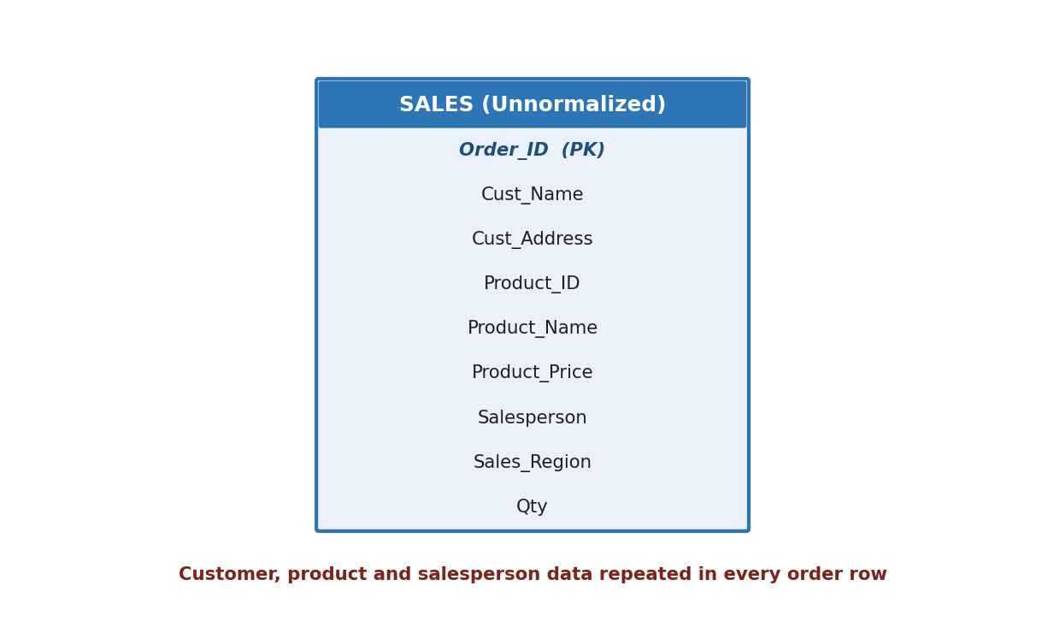
Figure 1: Unnormalized SALES table containing four merged entities
Identification of Problems
Table 2: Anomalies Identified
Anomaly | Example | Consequence
Insertion | A new product cannot be added until it is part of an order | Product catalog cannot be maintained independently
Update | Changing the price of 'Laptop' requires updating every order row containing it | Risk of inconsistent prices across rows
Deletion | Deleting order O1003 removes all record of customer Fathima N | Loss of customer master data
Redundancy | Cust_Address and Region repeated for every order line | Wasted storage, harder maintenance
Functional Dependencies
Table 3: Functional Dependencies
FD | Dependency
FD1 | Order_ID -> Cust_ID, Sales_ID, Order_Date
FD2 | Cust_ID -> Cust_Name, Cust_Address
FD3 | Product_ID -> Product_Name, Price
FD4 | Sales_ID -> Sales_Name, Region
FD5 | (Order_ID, Product_ID) -> Qty
Proposed Solution
The relation is normalized progressively: 1NF removes repeating product lines per order by splitting them into individual rows; 2NF removes partial dependencies of customer/product/salesperson attributes on only part of the order-product composite key; 3NF/BCNF removes any remaining transitive dependency, resulting in five independent relations - CUSTOMER, SALESPERSON, PRODUCT, ORDERS, and ORDER_ITEM.
Step-by-Step Explanation
- Step 1 (1NF): Separate each product ordered into its own ORDER_ITEM row instead of repeating order-level data per product.
- Step 2 (2NF): Move Cust_Name/Cust_Address to CUSTOMER, Sales_Name/Region to SALESPERSON, and Product_Name/Price to PRODUCT, since these depend only on Cust_ID, Sales_ID and Product_ID respectively, not on the full order key.
- Step 3 (3NF/BCNF): Confirm that no remaining non-key attribute depends on another non-key attribute; every determinant left (Cust_ID, Sales_ID, Product_ID, Order_ID) is a key of its own relation.
Table 4: Resulting Normalized Relations
Relation | Attributes | Primary Key
CUSTOMER | Cust_ID, Cust_Name, Address | Cust_ID
SALESPERSON | Sales_ID, Sales_Name, Region | Sales_ID
PRODUCT | Product_ID, Product_Name, Price | Product_ID
ORDERS | Order_ID, Cust_ID, Sales_ID, Order_Date | Order_ID
ORDER_ITEM | Order_ID, Product_ID, Qty | (Order_ID, Product_ID)
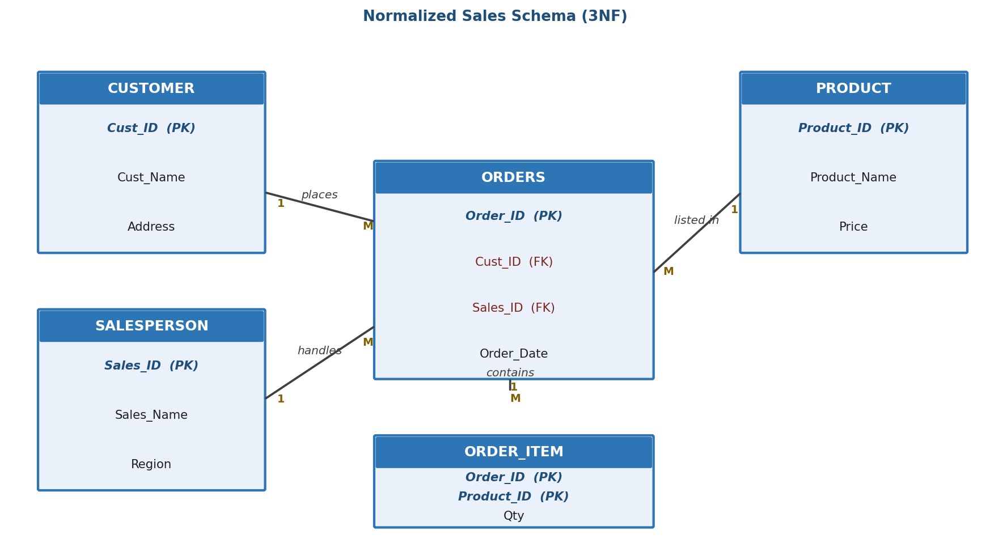
Figure 2: Normalized Sales Schema (3NF)
Required SQL
CREATE TABLE CUSTOMER (
Cust_ID VARCHAR(10) PRIMARY KEY,
Cust_Name VARCHAR(50) NOT NULL,
Address VARCHAR(100)
);
CREATE TABLE SALESPERSON (
Sales_ID VARCHAR(10) PRIMARY KEY,
Sales_Name VARCHAR(50) NOT NULL,
Region VARCHAR(30)
);
CREATE TABLE PRODUCT (
Product_ID VARCHAR(10) PRIMARY KEY,
Product_Name VARCHAR(50) NOT NULL,
Price DECIMAL(10,2) CHECK (Price > 0)
);
CREATE TABLE ORDERS (
Order_ID VARCHAR(10) PRIMARY KEY,
Cust_ID VARCHAR(10),
Sales_ID VARCHAR(10),
Order_Date DATE DEFAULT (CURRENT_DATE),
FOREIGN KEY (Cust_ID) REFERENCES CUSTOMER(Cust_ID),
FOREIGN KEY (Sales_ID) REFERENCES SALESPERSON(Sales_ID)
);
CREATE TABLE ORDER_ITEM (
Order_ID VARCHAR(10),
Product_ID VARCHAR(10),
Qty INT CHECK (Qty > 0),
PRIMARY KEY (Order_ID, Product_ID),
FOREIGN KEY (Order_ID) REFERENCES ORDERS(Order_ID),
FOREIGN KEY (Product_ID) REFERENCES PRODUCT(Product_ID)
);
-- Verification query: reconstruct the original flat report via JOIN
SELECT o.Order_ID, c.Cust_Name, p.Product_Name, p.Price, s.Sales_Name, oi.Qty
FROM ORDERS o
JOIN CUSTOMER c ON o.Cust_ID = c.Cust_ID
JOIN SALESPERSON s ON o.Sales_ID = s.Sales_ID
JOIN ORDER_ITEM oi ON o.Order_ID = oi.Order_ID
JOIN PRODUCT p ON oi.Product_ID = p.Product_ID;
Justification
Each of the five relations now stores a single fact type: customer master data, salesperson master data, product master data, order headers, and order line items. Updating a product's price requires changing exactly one row in PRODUCT instead of every order line, and a product or customer can exist even before any order references it, which removes both the update and insertion anomalies identified earlier.
Conclusion
Normalizing the SALES table into CUSTOMER, SALESPERSON, PRODUCT, ORDERS and ORDER_ITEM eliminates the redundancy that caused insertion, update and deletion anomalies, while the JOIN-based verification query confirms that the original reporting view can still be reconstructed without any loss of information.

Question 6
Given a dataset of customers and orders, write SQL queries using joins and subqueries to retrieve meaningful information such as frequent customers.
Introduction
Extracting business insight such as "who are the most frequent customers" is a routine but important requirement for any order-management system. This scenario models a CUSTOMER-ORDER schema and demonstrates how JOIN and subquery techniques together can answer such analytical questions correctly and efficiently.
Scenario Analysis
The dataset consists of a CUSTOMER table and an ORDER table linked by Customer_ID. "Frequent customers" is not a stored value - it is a derived metric based on counting how many orders each customer has placed, optionally above a chosen threshold. This requires aggregation across the join of the two tables rather than a simple SELECT.
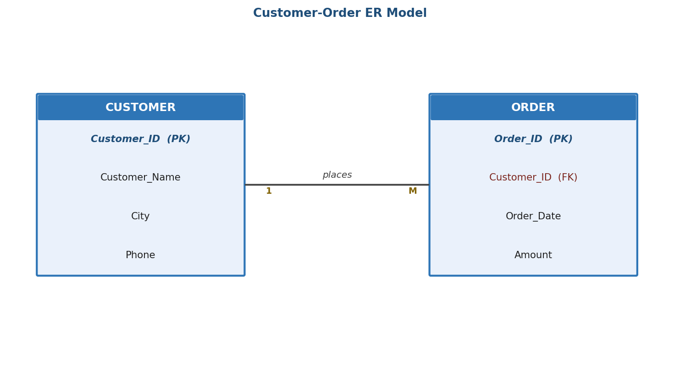
Figure 1: Customer-Order ER Model
Table 1: Sample CUSTOMER Data
Customer_ID | Customer_Name | City
C01 | Arjun Dev | Chennai
C02 | Meera Nair | Kochi
C03 | Suresh Babu | Chennai
Table 2: Sample ORDER Data
Order_ID | Customer_ID | Order_Date | Amount
O501 | C01 | 2026-01-04 | 3200
O502 | C01 | 2026-01-18 | 1800
O503 | C01 | 2026-02-02 | 2600
O504 | C02 | 2026-01-22 | 900
O505 | C03 | 2026-01-30 | 4100
Identification of Problems
- A simple SELECT * on ORDER shows raw transactions but does not summarize customer behaviour.
- Filtering "frequent" customers needs a HAVING clause, since WHERE cannot filter on an aggregated value.
- Ranking customers by total spend versus order count requires two different aggregate measures, which must be clearly distinguished in the query.
Proposed Solution
A combination of an INNER JOIN (to bring customer names alongside order data), GROUP BY/HAVING (to define "frequent"), and a subquery (to compare each customer's order count against the overall average) is used to answer the scenario comprehensively.
Step-by-Step Explanation
- Step 1: Join CUSTOMER and ORDER on Customer_ID so each order row carries the customer's name.
- Step 2: Group the joined rows by customer and count the orders per customer.
- Step 3: Apply HAVING COUNT(*) >= 3 to isolate frequent customers (threshold defined by business rule).
- Step 4: Use a subquery to compute the average number of orders across all customers, then compare each customer's count against it for a relative measure of frequency.
Required SQL
CREATE TABLE CUSTOMER (
Customer_ID VARCHAR(10) PRIMARY KEY,
Customer_Name VARCHAR(50) NOT NULL,
City VARCHAR(30)
);
CREATE TABLE ORDERS (
Order_ID VARCHAR(10) PRIMARY KEY,
Customer_ID VARCHAR(10),
Order_Date DATE,
Amount DECIMAL(10,2) CHECK (Amount > 0),
FOREIGN KEY (Customer_ID) REFERENCES CUSTOMER(Customer_ID)
);
-- Query 1: Total orders and spend per customer (JOIN + GROUP BY)
SELECT c.Customer_Name, COUNT(o.Order_ID) AS Order_Count, SUM(o.Amount) AS Total_Spent
FROM CUSTOMER c
JOIN ORDERS o ON c.Customer_ID = o.Customer_ID
GROUP BY c.Customer_Name;
-- Query 2: Frequent customers (3 or more orders)
SELECT c.Customer_Name, COUNT(o.Order_ID) AS Order_Count
FROM CUSTOMER c
JOIN ORDERS o ON c.Customer_ID = o.Customer_ID
GROUP BY c.Customer_Name
HAVING COUNT(o.Order_ID) >= 3;
-- Query 3: Customers ordering above the company-wide average order count (subquery)
SELECT Customer_Name FROM (
SELECT c.Customer_Name, COUNT(o.Order_ID) AS Order_Count
FROM CUSTOMER c JOIN ORDERS o ON c.Customer_ID = o.Customer_ID
GROUP BY c.Customer_Name
) AS CustomerOrders
WHERE Order_Count > (
SELECT AVG(cnt) FROM (
SELECT COUNT(*) AS cnt FROM ORDERS GROUP BY Customer_ID
) AS AvgCounts
);
-- Query 4: Customers who have never placed an order (NOT EXISTS subquery)
SELECT c.Customer_Name
FROM CUSTOMER c
WHERE NOT EXISTS (SELECT 1 FROM ORDERS o WHERE o.Customer_ID = c.Customer_ID);
Table 3: Expected Output of Query 2 (Frequent Customers)
Customer_Name | Order_Count
Arjun Dev | 3
Justification
Using JOIN before aggregation ensures the customer's descriptive attributes are available for reporting without duplicating them in the ORDER table. HAVING is used instead of WHERE because the frequency condition depends on an aggregate (COUNT), which is only evaluated after grouping. The nested subquery in Query 3 allows a dynamic, data-driven threshold rather than a hard-coded number, making the query resilient to changes in overall order volume.
Conclusion
Through a systematic combination of joins, grouping, HAVING filters and subqueries, the customer and order data can be transformed into actionable insights such as identifying frequent customers, top spenders, and inactive customers, directly supporting business decisions like loyalty targeting.

Question 7
A relation contains multi-valued dependencies. Analyze the structure and decompose it into 4NF, explaining the reasoning.
Introduction
A Multi-Valued Dependency (MVD) occurs when one attribute in a relation determines a set of values for another attribute, independently of a third attribute. Even relations that are already in BCNF can display redundancy caused by MVDs, which the Fourth Normal Form (4NF) is designed to remove. This scenario analyzes an employee-skill-project relation that exhibits this problem.
Scenario Analysis
Consider EMP_SKILL_PROJECT(Emp_ID, Skill, Project), which records that an employee possesses a set of skills and is independently assigned to a set of projects. Because Skill and Project have no direct relationship with each other - only with Emp_ID - every skill of an employee must be paired with every project of that employee to preserve meaning, causing the number of rows to multiply unnecessarily.
Table 1: Sample EMP_SKILL_PROJECT Data (MVD present)
Emp_ID | Skill | Project
E10 | Java | Billing System
E10 | Java | Inventory System
E10 | SQL | Billing System
E10 | SQL | Inventory System
E11 | Python | Analytics Portal
Identification of Problems
Table 2: Redundancy Caused by the MVD
Issue | Explanation
Row explosion | For E10 with 2 skills and 2 projects, 4 rows are needed instead of 2 + 2 facts
Update anomaly | Adding a new project for E10 requires inserting one row per existing skill
Deletion anomaly | Removing one skill row incorrectly appears to also remove project information if not handled carefully
No genuine composite fact | Skill and Project are independent of each other, so pairing them implies a false relationship
Multi-Valued Dependency Analysis
Table 3: MVDs and Candidate Key
Dependency | Type | Determinant a Superkey?
Emp_ID ->> Skill | Multi-valued dependency | No (violates 4NF)
Emp_ID ->> Project | Multi-valued dependency | No (violates 4NF)
{Emp_ID, Skill, Project} | Candidate key of the unnormalized relation | -
Since the relation contains a nontrivial MVD (Emp_ID ->> Skill) where Emp_ID is not a superkey, the relation violates 4NF even though it is already in BCNF (the only key is the full attribute set, so there are no partial or transitive FD violations).
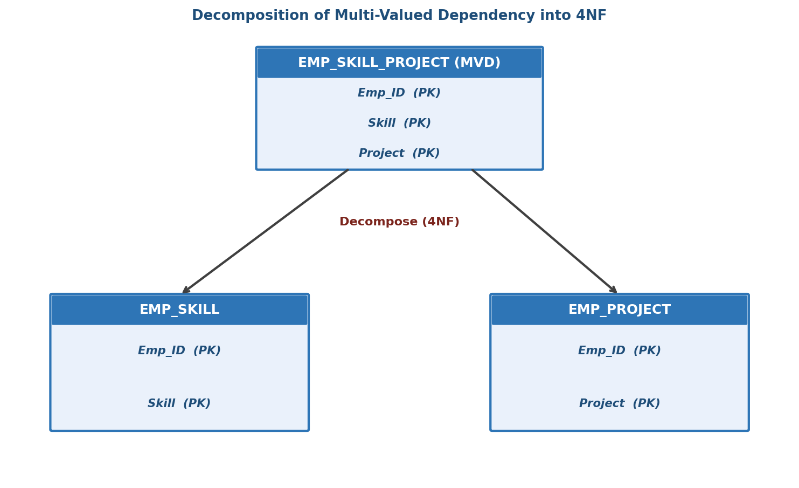
Figure 1: Decomposition of the MVD into two independent relations (4NF)
Proposed Solution
The relation is decomposed into two relations, each capturing exactly one independent multi-valued fact about the employee: EMP_SKILL(Emp_ID, Skill) and EMP_PROJECT(Emp_ID, Project). This is the standard 4NF decomposition rule for a relation R(A, B, C) with A ->> B: split into R1(A, B) and R2(A, C).
Step-by-Step Explanation
- Step 1: Recognize that Skill and Project are independent multivalued facts about Emp_ID, not about each other.
- Step 2: Split the relation into EMP_SKILL(Emp_ID, Skill) capturing the skill set.
- Step 3: Split the relation into EMP_PROJECT(Emp_ID, Project) capturing the project assignments.
- Step 4: Verify that each new relation has a composite candidate key with no remaining nontrivial MVD, satisfying 4NF.
Table 4: Final 4NF Relations
Relation | Attributes | Primary Key
EMP_SKILL | Emp_ID, Skill | (Emp_ID, Skill)
EMP_PROJECT | Emp_ID, Project | (Emp_ID, Project)
Required SQL
CREATE TABLE EMPLOYEE (
Emp_ID VARCHAR(10) PRIMARY KEY,
Emp_Name VARCHAR(50) NOT NULL
);
CREATE TABLE EMP_SKILL (
Emp_ID VARCHAR(10),
Skill VARCHAR(30),
PRIMARY KEY (Emp_ID, Skill),
FOREIGN KEY (Emp_ID) REFERENCES EMPLOYEE(Emp_ID)
);
CREATE TABLE EMP_PROJECT (
Emp_ID VARCHAR(10),
Project VARCHAR(50),
PRIMARY KEY (Emp_ID, Project),
FOREIGN KEY (Emp_ID) REFERENCES EMPLOYEE(Emp_ID)
);
-- Reconstructing the original (redundant) view when required for reporting
CREATE VIEW Emp_Skill_Project_View AS
SELECT s.Emp_ID, s.Skill, p.Project
FROM EMP_SKILL s
JOIN EMP_PROJECT p ON s.Emp_ID = p.Emp_ID;
Justification
After decomposition, E10's two skills need only two rows in EMP_SKILL and two projects need only two rows in EMP_PROJECT - four rows in total instead of the four redundant rows in the combined relation, with the saving becoming much larger as the number of skills and projects grows. The decomposition is lossless because Emp_ID is a common key in both relations, and each relation individually has no nontrivial MVD, satisfying 4NF.
Conclusion
Although EMP_SKILL_PROJECT was already free of ordinary functional-dependency anomalies, its multi-valued dependencies caused unnecessary row duplication. Decomposing the relation into EMP_SKILL and EMP_PROJECT removes this redundancy and brings the schema into 4NF while preserving all original information through a simple join.

Question 8
A database designer used improper constraints, leading to inconsistent data. Evaluate the schema and suggest appropriate integrity constraints.
Introduction
Integrity constraints are the database's first line of defense against invalid data; when they are missing, misapplied, or too permissive, the application layer becomes solely responsible for correctness, which is unreliable in practice. This scenario evaluates a poorly constrained EMPLOYEE_PAYROLL schema and proposes a corrected set of constraints.
Scenario Analysis
The designer created EMPLOYEE_PAYROLL(Emp_ID, Emp_Name, Email, Dept_ID, Salary, Join_Date, Status) without a primary key on Emp_ID, without a foreign key linking Dept_ID to DEPARTMENT, without a CHECK on Salary, and with Email left nullable and non-unique. As a result, duplicate employee records, orphaned department references, negative salaries and duplicate email addresses have all been observed in the data.
Table 1: Existing (Flawed) Schema Definition
Column | Data Type | Constraint as Designed | Problem
Emp_ID | VARCHAR(10) | None | Duplicate employee IDs possible
Email | VARCHAR(50) | Nullable, no UNIQUE | Duplicate/missing emails
Dept_ID | VARCHAR(10) | No FOREIGN KEY | Can reference a non-existent department
Salary | DECIMAL(10,2) | No CHECK | Negative or zero salaries accepted
Status | VARCHAR(10) | Free text, no domain restriction | Inconsistent values like 'active','Active','ACT'
Identification of Problems
Table 2: Data Inconsistencies Observed
Inconsistency | Root Cause | Business Impact
Two rows with Emp_ID = 'E205' | No PRIMARY KEY | Ambiguous payroll processing
Dept_ID = 'D99' does not exist in DEPARTMENT | No FOREIGN KEY | Orphaned employee record
Salary = -5000 recorded for one row | No CHECK constraint | Incorrect payroll calculation
Same email used by two employees | No UNIQUE constraint | Login/notification conflicts
Status values: 'active', 'Active', 'ACT' | No domain/ENUM restriction | Reports undercount active employees
Proposed Solution
Each identified inconsistency is mapped to a specific SQL integrity constraint that prevents the corresponding invalid state at the database level, rather than relying on application-side validation alone.
Step-by-Step Explanation
- Step 1: Add a PRIMARY KEY on Emp_ID to guarantee entity integrity and eliminate duplicate employees.
- Step 2: Add a FOREIGN KEY from Dept_ID to DEPARTMENT(Dept_ID) to guarantee referential integrity.
- Step 3: Add a CHECK (Salary > 0) constraint to enforce the business rule that salary must be positive.
- Step 4: Add UNIQUE and NOT NULL constraints on Email to prevent duplicate or missing contact addresses.
- Step 5: Restrict Status to a fixed domain using CHECK (Status IN ('ACTIVE','INACTIVE','ON_LEAVE')) and apply DEFAULT 'ACTIVE' for new hires.
Table 3: Before vs After Comparison
Column | Before | After
Emp_ID | No constraint - duplicates possible | PRIMARY KEY - uniqueness enforced
Dept_ID | No FK - invalid department allowed | FOREIGN KEY - only valid departments allowed
Salary | No CHECK - any value allowed | CHECK (Salary > 0)
Email | Nullable, duplicate allowed | NOT NULL, UNIQUE
Status | Free text | CHECK domain list + DEFAULT 'ACTIVE'
Required SQL
-- Corrected schema
CREATE TABLE DEPARTMENT (
Dept_ID VARCHAR(10) PRIMARY KEY,
Dept_Name VARCHAR(50) NOT NULL
);
CREATE TABLE EMPLOYEE_PAYROLL (
Emp_ID VARCHAR(10) PRIMARY KEY,
Emp_Name VARCHAR(50) NOT NULL,
Email VARCHAR(50) NOT NULL UNIQUE,
Dept_ID VARCHAR(10),
Salary DECIMAL(10,2) CHECK (Salary > 0),
Join_Date DATE DEFAULT (CURRENT_DATE),
Status VARCHAR(10) DEFAULT 'ACTIVE'
CHECK (Status IN ('ACTIVE','INACTIVE','ON_LEAVE')),
FOREIGN KEY (Dept_ID) REFERENCES DEPARTMENT(Dept_ID)
);
-- Migrating an existing flawed table: adding constraints after the fact
ALTER TABLE EMPLOYEE_PAYROLL ADD CONSTRAINT chk_salary CHECK (Salary > 0);
ALTER TABLE EMPLOYEE_PAYROLL ADD CONSTRAINT uq_email UNIQUE (Email);
ALTER TABLE EMPLOYEE_PAYROLL
ADD CONSTRAINT fk_dept FOREIGN KEY (Dept_ID) REFERENCES DEPARTMENT(Dept_ID);
ALTER TABLE EMPLOYEE_PAYROLL MODIFY Email VARCHAR(50) NOT NULL;
-- Query to detect existing violations before applying the constraints
SELECT Emp_ID, COUNT(*) FROM EMPLOYEE_PAYROLL GROUP BY Emp_ID HAVING COUNT(*) > 1;
SELECT * FROM EMPLOYEE_PAYROLL WHERE Salary <= 0;
Justification
Placing these rules as database constraints, rather than only in application code, ensures the guarantee holds regardless of which application, script, or user connects to the database - a requirement often referred to as defense at the data layer. The ALTER TABLE statements also show how the fix can be applied to an existing, already-populated table, after first identifying and correcting the specific rows that currently violate each new rule.
Conclusion
The improperly constrained EMPLOYEE_PAYROLL table allowed duplicate keys, orphaned foreign references, invalid salaries, duplicate emails and inconsistent status values. Adding PRIMARY KEY, FOREIGN KEY, CHECK, UNIQUE, NOT NULL and DEFAULT constraints directly targets each observed inconsistency and restores entity, referential and domain integrity to the schema.

Question 9
For a given relational schema, analyze the presence of join dependencies and decompose it into 5NF to remove redundancy.
Introduction
Fifth Normal Form (5NF), also called Project-Join Normal Form, addresses redundancy caused by join dependencies (JDs) that are not implied by the candidate keys of a relation. This scenario examines a supplier-part-project relation that is already in 4NF but still exhibits redundancy that only a three-way decomposition can remove.
Scenario Analysis
Consider SUPPLIER_PART_PROJECT(Supplier_ID, Part_ID, Project_ID), which records that a supplier supplies a part for a project, subject to the business rule: 'If supplier S supplies part P, and supplier S supplies project J, and part P is used in project J, then supplier S supplies part P for project J.' This circular business rule is a classic signature of a join dependency that cannot be decomposed losslessly into only two relations.
Table 1: Sample SUPPLIER_PART_PROJECT Data
Supplier_ID | Part_ID | Project_ID
S1 | P1 | J1
S1 | P2 | J1
S2 | P1 | J1
S1 | P1 | J2
Identification of Problems
Table 2: Redundancy and Anomalies
Issue | Explanation
Spurious tuple risk | Decomposing into only two of the three relations and rejoining can generate a row that never existed
Redundant combinations | Every valid combination of supplier-part-project must be stored explicitly, even when implied by simpler pairwise facts
Update anomaly | Adding a new part for an existing supplier-project pair may require inserting several new rows
Join Dependency Analysis
Table 3: Join Dependency and Candidate Key
Element | Detail
Candidate Key | {Supplier_ID, Part_ID, Project_ID} (whole relation)
Join Dependency (JD) | *{(Supplier_ID, Part_ID), (Supplier_ID, Project_ID), (Part_ID, Project_ID)}
5NF Rule | A relation is in 5NF if every join dependency is implied by its candidate keys
Violation | The JD above is NOT implied by the single all-attribute candidate key, so the relation violates 5NF
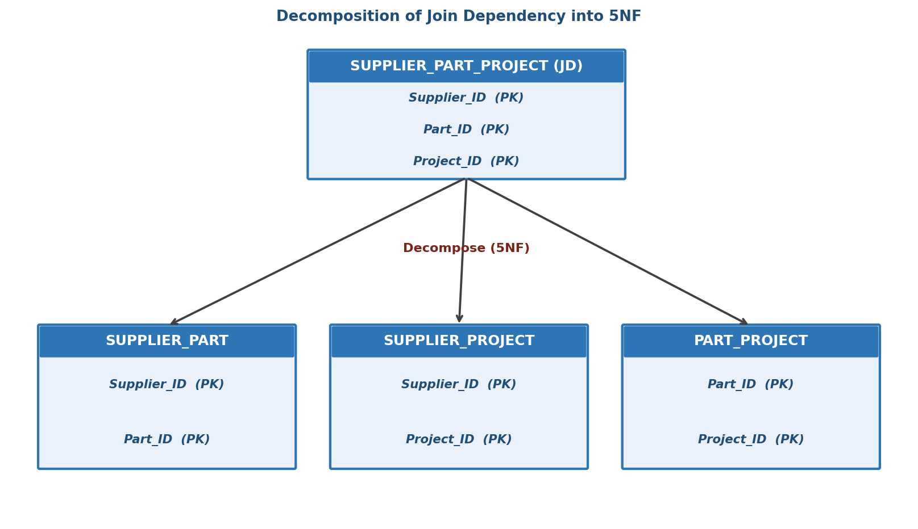
Figure 1: Decomposition of the Join Dependency into three binary relations (5NF)
Proposed Solution
The relation is decomposed into three binary relations, one for each pairwise combination named in the join dependency: SUPPLIER_PART, SUPPLIER_PROJECT, and PART_PROJECT. Re-joining all three (not just two) reconstructs the original relation exactly, satisfying the lossless-join property specific to 5NF.
Step-by-Step Explanation
- Step 1: Identify the circular business rule connecting Supplier, Part and Project pairwise.
- Step 2: Create SUPPLIER_PART(Supplier_ID, Part_ID) recording which parts each supplier can supply.
- Step 3: Create SUPPLIER_PROJECT(Supplier_ID, Project_ID) recording which projects each supplier serves.
- Step 4: Create PART_PROJECT(Part_ID, Project_ID) recording which parts each project requires.
- Step 5: Verify the 3-way natural join of these relations reproduces exactly the original data (no spurious or missing rows).
Table 4: Final 5NF Relations
Relation | Attributes | Primary Key
SUPPLIER_PART | Supplier_ID, Part_ID | (Supplier_ID, Part_ID)
SUPPLIER_PROJECT | Supplier_ID, Project_ID | (Supplier_ID, Project_ID)
PART_PROJECT | Part_ID, Project_ID | (Part_ID, Project_ID)
Required SQL
CREATE TABLE SUPPLIER_PART (
Supplier_ID VARCHAR(10),
Part_ID VARCHAR(10),
PRIMARY KEY (Supplier_ID, Part_ID)
);
CREATE TABLE SUPPLIER_PROJECT (
Supplier_ID VARCHAR(10),
Project_ID VARCHAR(10),
PRIMARY KEY (Supplier_ID, Project_ID)
);
CREATE TABLE PART_PROJECT (
Part_ID VARCHAR(10),
Project_ID VARCHAR(10),
PRIMARY KEY (Part_ID, Project_ID)
);
-- Verification: 3-way natural join must reconstruct the original relation exactly
SELECT sp.Supplier_ID, sp.Part_ID, spj.Project_ID
FROM SUPPLIER_PART sp
JOIN SUPPLIER_PROJECT spj ON sp.Supplier_ID = spj.Supplier_ID
JOIN PART_PROJECT pp ON sp.Part_ID = pp.Part_ID AND spj.Project_ID = pp.Project_ID;
Verification and Advantages
Table 5: Advantages of the 5NF Decomposition
Advantage | Explanation
No spurious tuples | Joining all three relations reproduces exactly the valid supplier-part-project combinations
Minimal redundancy | Each pairwise fact is stored exactly once, independent of the other two dimensions
Easier maintenance | Adding a new supplier-part relationship does not require touching project data
Justification
Unlike simpler normal forms, 5NF specifically targets join dependencies where no two-way decomposition is lossless; only the three-way split above avoids both loss of information and the introduction of spurious rows on rejoin. The verification query confirms that joining SUPPLIER_PART, SUPPLIER_PROJECT and PART_PROJECT together reconstructs the original data, validating that no information was lost during decomposition.
Conclusion
The SUPPLIER_PART_PROJECT relation exhibited a join dependency not implied by its candidate key, violating 5NF despite already satisfying 4NF. Decomposing it into three binary relations - SUPPLIER_PART, SUPPLIER_PROJECT and PART_PROJECT - removes this redundancy while guaranteeing a lossless three-way join, achieving full 5NF compliance.

Question 10
A system uses inefficient SQL queries for data retrieval. Analyze the queries and optimize them using joins, indexing concepts, or query restructuring.
Introduction
As tables grow, poorly written SQL queries that were acceptable during development can become serious performance bottlenecks in production. This scenario analyzes a set of inefficient queries running against an ORDERS/CUSTOMER schema, diagnoses why each is slow, and restructures them using proper joins, indexing, and query rewriting techniques.
Scenario Analysis
The reporting module of an order-management system runs a query every time a staff member searches for a customer's orders. The existing query uses a correlated subquery inside a WHERE clause, applies a function to the indexed date column, and retrieves all columns using SELECT *, causing the report to take several seconds even though the underlying tables are indexed on their primary keys.
Existing Inefficient Query
-- Original (inefficient) query
SELECT *
FROM ORDERS o
WHERE o.Customer_ID IN (
SELECT Customer_ID FROM CUSTOMER WHERE City = 'Chennai'
)
AND YEAR(o.Order_Date) = 2026
ORDER BY o.Amount DESC;
Identification of Problems
Table 1: Problems Identified in the Existing Query
Problem | Explanation | Performance Impact
SELECT * | Retrieves every column even though only a few are needed | Extra I/O and network transfer
IN (subquery) | Executed as a semi-join, but can be slower than an explicit JOIN on some optimizers | Redundant re-evaluation on large CUSTOMER tables
YEAR(Order_Date) = 2026 | Wrapping the indexed column in a function | Index on Order_Date cannot be used (non-sargable predicate)
No index on Customer_ID / City | Full table scans required for the filter | Slow lookups as table size grows
Proposed Solution
The query is restructured to use an explicit INNER JOIN instead of the IN subquery, the date filter is rewritten as a sargable range condition, only the required columns are selected, and supporting indexes are created on the columns used for filtering and joining.
Step-by-Step Explanation
- Step 1: Replace SELECT * with only the columns actually required by the report.
- Step 2: Replace the IN (subquery) with an explicit JOIN between ORDERS and CUSTOMER, letting the optimizer choose the most efficient join algorithm.
- Step 3: Rewrite YEAR(Order_Date) = 2026 as a BETWEEN range condition so the existing index on Order_Date can be used directly.
- Step 4: Create composite and single-column indexes on the columns used in JOIN and WHERE clauses.
- Step 5: Use EXPLAIN to confirm the optimizer now performs an index seek instead of a full table scan.
Optimized SQL
-- Supporting indexes
CREATE INDEX idx_customer_city ON CUSTOMER(City);
CREATE INDEX idx_orders_custid_date ON ORDERS(Customer_ID, Order_Date);
-- Optimized query
SELECT o.Order_ID, o.Order_Date, o.Amount, c.Customer_Name
FROM ORDERS o
JOIN CUSTOMER c ON o.Customer_ID = c.Customer_ID
WHERE c.City = 'Chennai'
AND o.Order_Date >= '2026-01-01'
AND o.Order_Date < '2027-01-01'
ORDER BY o.Amount DESC;
-- Verify the optimizer's execution plan
EXPLAIN SELECT o.Order_ID, o.Order_Date, o.Amount, c.Customer_Name
FROM ORDERS o
JOIN CUSTOMER c ON o.Customer_ID = c.Customer_ID
WHERE c.City = 'Chennai'
AND o.Order_Date >= '2026-01-01'
AND o.Order_Date < '2027-01-01'
ORDER BY o.Amount DESC;
Table 2: Before vs After Comparison
Aspect | Before (Original Query) | After (Optimized Query)
Column selection | SELECT * (all columns) | Only required columns selected
Customer filter | IN (subquery) on CUSTOMER | Explicit INNER JOIN on Customer_ID
Date filter | YEAR(Order_Date) = 2026 (non-sargable) | Order_Date BETWEEN range (sargable, index-usable)
Index support | No supporting index | Composite index on (Customer_ID, Order_Date); index on City
Execution plan | Full table scan on ORDERS and CUSTOMER | Index seek using idx_orders_custid_date and idx_customer_city
SQL Optimization Techniques Applied
Table 3: Optimization Techniques and Their Advantage
Technique | Advantage
Explicit JOIN instead of IN subquery | Allows the optimizer to choose hash/merge/nested-loop join strategies efficiently
Sargable predicates (avoid wrapping indexed columns in functions) | Enables index seeks instead of full table scans
Composite indexing on (Customer_ID, Order_Date) | Speeds up both the join and the date range filter in one index
Column pruning (avoid SELECT *) | Reduces I/O, memory usage and network transfer
EXPLAIN plan verification | Confirms the query is actually using the intended indexes before deployment
Justification
Rewriting the date filter as a range avoids forcing the database to evaluate YEAR() for every row before it can apply the index, which is why non-sargable predicates are a well-known cause of slow queries. The composite index on (Customer_ID, Order_Date) directly matches the join and filter columns used together, so a single index lookup satisfies both conditions instead of the engine needing two separate scans. Selecting only the needed columns further reduces the amount of data that must be read from disk and sent across the network for every report execution.
Conclusion
The original query's slowness was caused by a non-sargable date filter, an implicit subquery-based filter, unnecessary column retrieval, and the absence of supporting indexes. Restructuring the query into an explicit join with sargable predicates, targeted column selection, and appropriate composite indexing significantly reduces I/O and allows the database optimizer to use index seeks instead of full table scans, directly improving the report's response time.

